Book Cup 2017: Escape to Everywhere
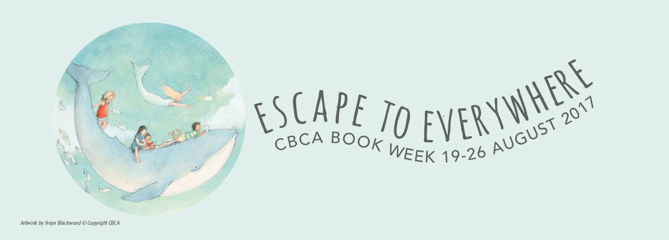

Novels:
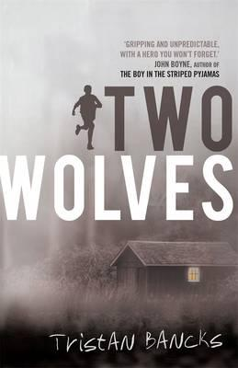
Two Wolves by Tristan Banckes
One afternoon, police officers show up at Ben Silver’s front door. Minutes after they leave, his parents arrive home. Ben and his little sister Olive are bundled into the car and told they’re going on a holiday. But are they?
It doesn’t take long for Ben to realise that his parents are in trouble. Ben’s always dreamt of becoming a detective – his dad even calls him ‘Cop’. Now Ben gathers evidence and tries to uncover what his parents have done.
The problem is, if he figures it out, what does he do? Tell someone? Or keep the secret and live life on the run?

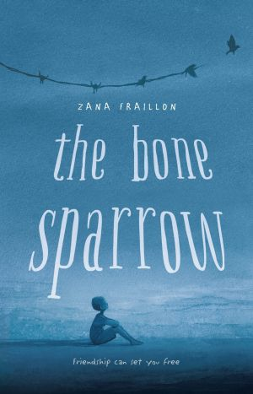
SHORTLISTED IN 2017 ON CHILDREN’S BOOK COUNCIL FOR CHILDREN’S BOOK WEEK
The Bone Sparrow by Zana Fraillon
Subhi is a refugee. Born in an Australian permanent detention center after his mother and sister fled the violence of a distant homeland, Subhi has only ever known life behind the fences. But his world is far bigger than that—every night, the magical Night Sea from his mother's stories brings him gifts, the faraway whales sing to him, and the birds tell their stories. And as he grows, his imagination threatens to burst beyond the limits of his containment.
The most vivid story of all, however, is the one that arrives one night in the form of Jimmie—a scruffy, impatient girl who appears on the other side of the wire fence and brings with her a notebook written by the mother she lost. Unable to read it herself, she relies on Subhi to unravel her family's love songs and tragedies.
Subhi and Jimmie might both find comfort—and maybe even freedom—as their tales unfold. But not until each has been braver than ever before

Zita the Spacegirl, by Ben Hatke
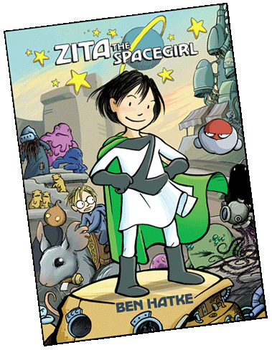
Zita's life took a cosmic left turn in the blink of an eye.
When her best friend is abducted by an alien doomsday cult, Zita leaps to the rescue and finds herself a stranger on a strange planet. Humanoid chickens and neurotic robots are shocking enough as new experiences go, but Zita is even more surprised to find herself taking on the role of intergalactic hero. Before long, aliens in all shapes and sizes don't even phase her. Neither do ancient prophecies, doomed planets, or even a friendly con man who takes a mysterious interest in Zita's quest.
Zita the Spacegirl is a fun, captivating tale of friendship and redemption from Flight veteran Ben Hatke. It also has more whimsical, eye-catching, Miyazaki-esque monsters than you can shake a stick at

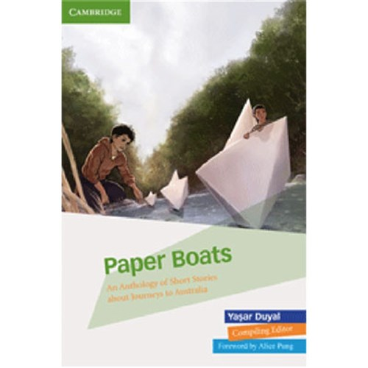
3 short stories from this collection
Paper Boats is a compelling collection of 21 short stories for Years 7 and 8 written by students from immigrant, refugee or asylum seeker backgrounds, reflecting their origins, journey and arrival in Australia. Sometimes disturbing, sometimes uplifting, these powerful stories let students glimpse the hardship and dangers other students have endured to reach this country.
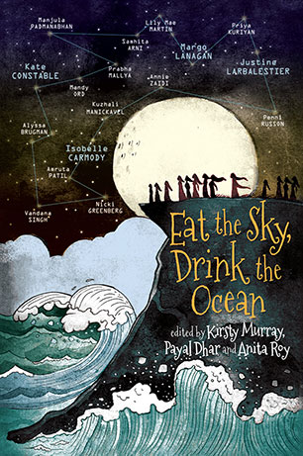
Short story called The Runners (comic nature)
Be transported into dystopian cities and other-worldly societies. Be amazed and beguiled by a nursery story with a reverse twist, a futuristic take on TV cooking shows, a playscript with tentacles - and more, much more. Plunge in and enjoy!
A collection of sci-fi and fantasy writing, including six graphic stories, showcasing twenty stellar writers and artists from India and Australia: Isobelle Carmody, Penni Russon, Justine Larbalestier, Margo Lanagan, Lily Mae Martin, Kuzhali Manickavel, Prabha Mallya, Annie Zaidi, Kate Constable, Vandana Singh, Mandy Ord, Priya Kuriyan, Manjula Padmanabhan, Samhita Arni, Alyssa Brugman, Nicki Greenberg and Amruta Patil

Film: Hunt for the Wilderpeople
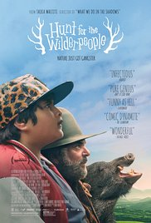
Raised on hip-hop and foster care, defiant city kid Ricky gets a fresh start in the New Zealand countryside. He quickly finds himself at home with his new foster family: the loving Aunt Bella, the cantankerous Uncle Hec, and dog Tupac. When a tragedy strikes that threatens to ship Ricky to another home, both he and Hec go on the run in the bush. As a national manhunt ensues, the newly branded outlaws must face their options: go out in a blaze of glory or overcome their differences and survive as a family. Equal parts road comedy and rousing adventure story, director Taika Waititi (WHAT WE DO IN THE SHADOWS, upcoming THOR: RAGNORAK) masterfully weaves lively humor with emotionally honest performances by Sam Neill and Julian Dennison. A hilarious, touching crowd-pleaser, HUNT FOR THE WILDERPEOPLE reminds us about the journey that growing up is (at any age) and those who help us along the way.

