Year 8 Book Cup 2017
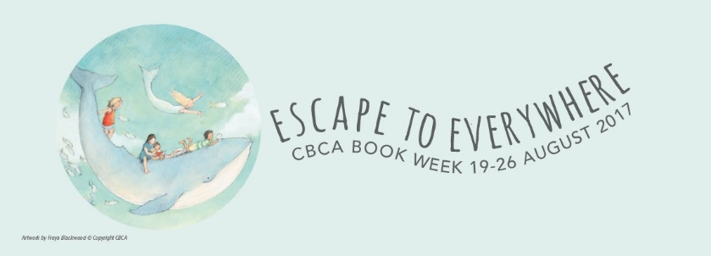
Here is a list of activities all about our Book Week 2017 list.
Negotiate with your English teacher which activities you will do.
- Note down or recall two quotes from different Book Cup texts, explain the significance of them to each text and how they describe the theme of ‘escape’ either physically, emotionally or mentally.

- Design and make a birthday, farewell, or sympathy card from one character in the texts to another.

- Write a list of at least 5 things (real or imagined) that the characters in any of the texts are ‘escaping.’

- Write a short review (approx. 100 to 150 words) of any of the Book Cup texts.

- Compose and write an original version of one of Subhi’s family love songs from The Bone Sparrow based on the events in the novel.

- Make and write a post card to send to family or friends from any of the characters in the texts.

- Rank 1 to 5 the most important items to have when ‘escaping’ based on any of the Book Cup texts.

- Draw a detailed map based on the escape in any of the Book Cup texts.

- Write a short dialogue of two characters from different Book Cup texts, if they could have met.

- Compose a short story based on the Book Week theme of ‘Escape to Everywhere.’

- Based on the Book Cup texts, list and explain the main ‘life lessons’ the characters have learnt from escaping.

- Write the eulogy delivered at one of the deceased characters funeral.

- Compare the ‘escape’ experiences of two characters from different Book Cup texts using a Venn Diagram or comparison table.

- Predict what might have happened if a character in one of the Book Cup text did not escape.

- Redesign the cover of one of the Book Cup texts to reflect the theme of ‘escape.’

- Create a newspaper front page, magazine or online news article describing the events of one of the Book Cup text. Include a suitable headline and images.

- “It takes two”: Evaluate the benefits of two characters and support they provide each other in any of the Book Cup texts.

- Illustrate by drawing or painting a scene or scene from of the written Book Cup texts.

- Write an inspirational 2 min speech inspired one or more of the Book Cup texts.

- Write a letter or email to the author or producers of one of the Book Cup texts describing your opinion of the text, and asking at least one question.

- Compare the events in one of the Book Cup texts to something that has happened in your life, or a real life news story.

- Make puppets or models of one or more characters from the Book Cup texts.

- Describe one of the Book Cup texts or characters in a list of 20 words or haiku.

- Create a Find-a-Word or Cross Word based on one of more of the Book Cup texts. (Puzzlemaker.discoveryeducation.com/ is useful for this activity).

- Present a silent charade to class on one of the Book Cup texts, see if they can guest which text.

- Create an eye-catching poster featuring characters, quotes and images from one or more of the Book Cup texts.

