SLASA Reference Generator
This tool, developed by the School Library Association of South Australia, will help you to correctly format and organise your reference list.
The generator:
- Creates correctly formatted citations for a range of sources, to copy into your reference list
- Rollover elements to see a definition for each part of the citation
- Provides examples of correct in-text referencing for each source
https://org.slasa.asn.au/apa
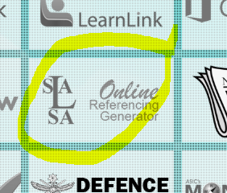
Via http://campus.ggcsad.sa.edu.au/web/gg/
www.thielelibrary.website/research-and-referencing.html

